|  |
| --- |
| St10176153 |
| Luyanda Mazibuko |

25/08/23

# WeDE5020: POE PART 1

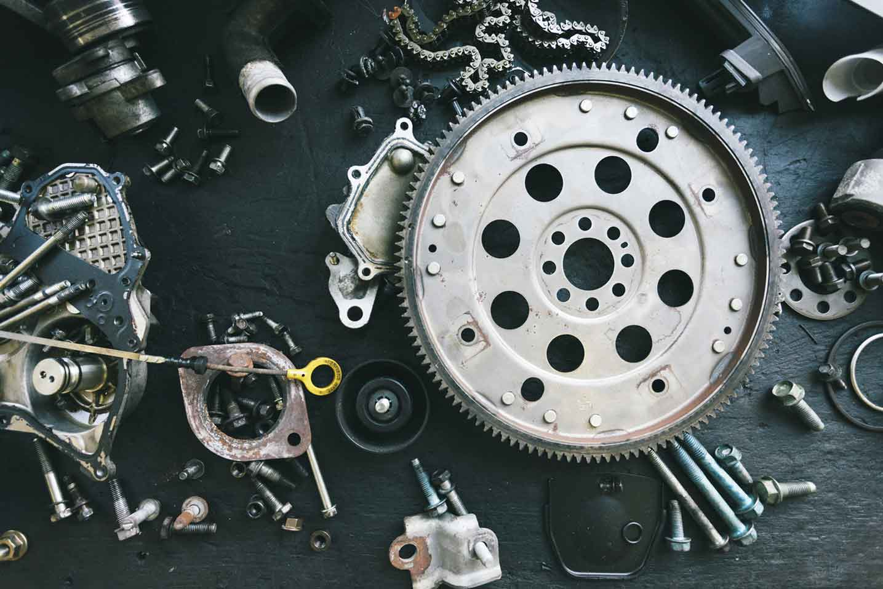

# Table of Content:

**Introduction: Ideation & Sourcing assets……………3&4**

**Website page and Content Structure……………………..5**

**Part 2…………………………………………………………………..6&7**

**Reference List……………………………………………………….8**

# Introduction: Ideation & Sourcing ASSETS

# SPRINKLE TOGETHER IS AN NPO that was created BY THE CITIZENS OF STANDERTON, MPUMALANGA. The Sprinkle together ORGANIZATION WAS CREATED TO HELP Underprivileged SCHOOLS GIVE YOUNG STUDENTS Opportunities to LEARN MORE ABOUT TECHNOLOGY AND HOW BASIC TECH DEVICES WORK. AS IT IS A SMALL ENTITY, THE ORGANIZATION WAS FOUNDED UPON THE URGE TO HELP THE CHILDREN IN NEED AS THE FOURTH INDUSTRIAL REVOLUTION IS THE FUTURE, IN DUE TIME we WILL BE LIVING IN An ai world. as THE NEXT GENERATION GROWS UP IT IS ESSENTIAL FOR YOUNG CHILDREN TO KNOW TECHNOLOGY MORE ESPECIALLY HOW A COMPUTER WORKS, HOW A CELL PHONE WORKS AND WHAT IS TECHNOLOGY. SPRINKLE TOGETHER FOUNDATION HAS A Mission TO HAVE EVERY YOUNG STUDENT and adult LEARN TECHNOLOGY AS OURS START WILL BE IN STANDERTON, MPUMALANGA GROWING WORLDWIDE GIVING YOUNG STUDENT AND WILLING ADULTS the opportunity and ACCESS TO TOOLS THAT ARE ESSENTIAL FOR THEM TO LEARN TECHNOLOGY. SPRINKLE TOGETHER ORGANIZATION IS AN NPO meaning it is an organization that RELIES MORE ON DONATIONS to help AND PURCHASES FROM THE WEBSITE TO GIVE OUT THE HELPING HAND TO Underprivileged schools as THE PURCHASES MADE ON THE WEBSITE ALSO GO DIRECTLY TO the donation pile to help THE STUDENTS in GETTING MORE EQUIPMENT AND TECHNOLOGY TO LEARN AS MUCH ABOUT Technology as possible. There IS ALSO SPACE IN THE Sprinkle FOUNDATION FOR PEOPLE TO Donate EQUIPMENT TO SCHOOLS to HELPING MORE CHILDREN LEARN TECHNOLOGY. The sprinkle together organization will strive and work hard in providing the promise made to the schools and make sure that at the end of the day everybody has developed basic tech skills and we HAVE TRULY Sprinkled together giving HOPE AND PCS EVERYWHERE Possible. This is the Sprinkle together organization sprinkling the seeds of technology for THE FUTURE OF SCHOOLS AND YOUNG CHILDREN.

# I’ll be sourcing images from istockPHOto:

Image 1: Logo is my design created using visual studios  
(Luyanda, 2023)

Image 2: Bishop, K. 24 March 2011. Box of Supplies. iStockphoto

Image 3: Watt, A. 13 August 2021. Donate. iStockphoto

Image 4: PeopleImages. 20 May 2020. Family. iStockphoto

Image 5: PixelCatchers. 27 July 2018. Opening. iStockphoto

# Website page and Content Structure:

1. **Home Page:**

* **Slogan**
* **Logo**
* **Link to other pages**
* **Summary paragraph describing the organization**

1. **About Us:**

* **Overview what the organization is**
* **Mission of the organization**
* **Goal the organization**

1. **Goods and Service:**

* **Donation form**
* **Goods sold by the Organization**

1. **Contact Information:**

* **Email Address**
* **Google Maps location**
* **Telephone number**

**Part 2**

**Improvements to Part 1 Document:**

The improvements made on part one document well on page 5 on the website page and contents structure page: number 3 formally known as products and service but now changed to goods and service as it is an NPO so no products can be sold for any gain but goods can be purchased to be donated and help support schools and underprivileged families.

**Improvements made on Website:**

Improvements made on the website which changing the title of the AML pay from products and services to goods and services. The improvements were made on the part one document was changing the name of the products on the products and services page from products to goods which can be found online 13, 16 and 18.

# Reference List:

Bishop, K. 2011. Care Package. [Online]. Available at: <https://www.istockphoto.com/en/vector/care-package-box-full-of-supplies-gm455416897-16099236?phrase=care+packages+for+homeless> [Accessed 10 September 2023].

Mazibuko, L. 2023. Logo with sprinkles shaped in S letter form containing PC and Smartphone next to the letters. [Personal Drawing]. Johannesburg: Unpublished.

PeopleImages. 2020. Couples hands holding paper cutout of a perfect family. [Online]. Available at: <https://www.istockphoto.com/en/photo/closeup-of-a-couples-hands-holding-paper-cutout-of-a-perfect-family-symbol-of-home-gm1398079833-452327168?phrase=donation+for+kids+in+south+africa> [Accessed 10 September 2023].

PixelCatchers. 2018. Little girl opens moving box of toys smiling at camera. [Online]. Available at: <https://www.istockphoto.com/en/photo/little-girl-opens-moving-box-of-toys-smiling-at-camera-gm1002768294-270964806?phrase=care+packages+for+kids+in+south+africa> [Accessed 10 September 2023].

Watt, A. 2021. Food Bank.[Online]. Available at: <https://www.istockphoto.com/en/photo/close-up-of-a-young-woman-carrying-a-box-of-food-donations-gm1333790678-416160755?phrase=food+donation+for+schoolkids+in+south+africa> [Accessed 10 September 2023].